README FILE

AALIYAH AND NICOL

Hello, and welcome to the readme file of our assignment.

This readme file contains the instructions for our assignment and how it runs.

To get started to view our assignment, you need to store the assignment within your xampp on your computer and store it within the htdocs folder.

From there you will need to ensure that your Xampp has Apache and MySQL running, from there run our SQL file clothingstore.sql on your phpMyAdmin to ensure connection errors do not occur, as well as the following under user accounts/privileges, server name: localhost , username: AaliyahNicol, password: AaliyahNicol within the database: ClothingStore.

When the database connectivity is working everything within the website should run with no errors.

To start the website open it from http://127.0.0.1/ in your browser or open it is VS Code and run it from the:

StartUp.php (this is our first page of our website). The startup page has an introduction of what the website is about and a button that will launch to the loading.php page, where you are to select if you are an admin or user.



loading.php(prompts user to select if they are an admin or user)

Admin redirects to adminLogin.php (where admin can login if they have an account as an Admin if not they can register)

User redirects to userLogin.php(where user can login if they have an account and their account has been verified by admin, If not they can register and wait till their account it verified)

adminLogin.php will take them to their adminHomePage.php (where they have options to select from)

User controls allows admins to add, delete and update users

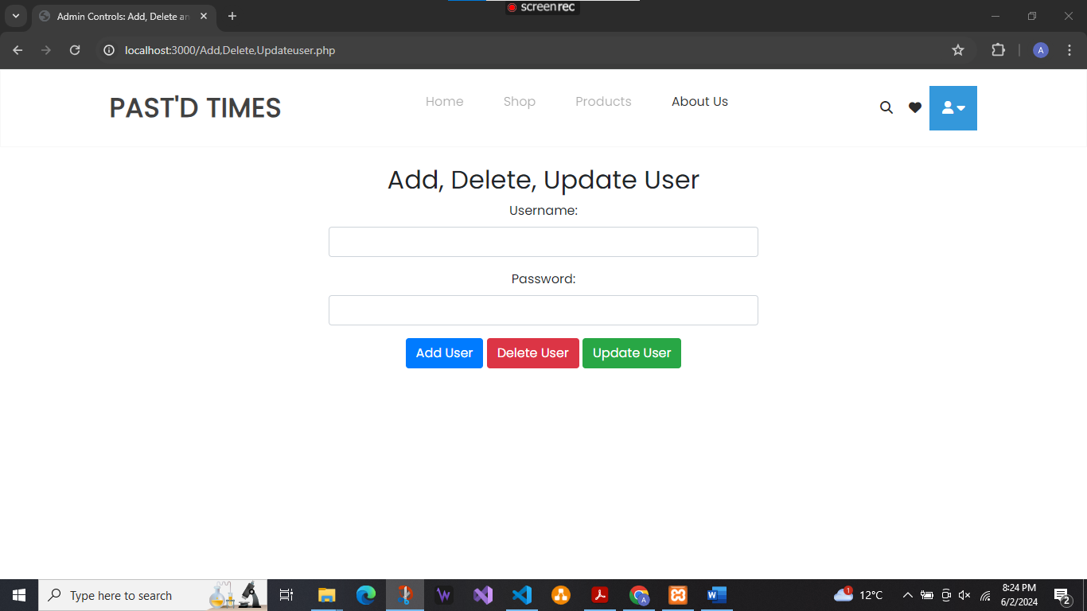

Item controls allows admins to add,delete and edit clothes from the admin tables and user seller items, as well as upload them to the shop.

OrderLine shows the admin how many orders there are in the order table.

Message Seller allows them to messages the sellers

Verify users allows them to verify user accounts so that they can login.

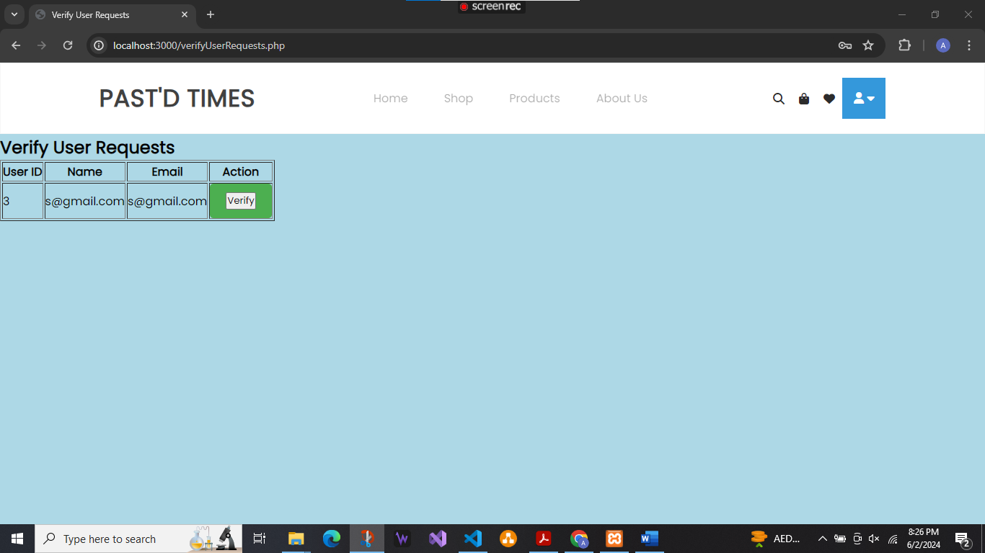

Sell requests allows admins to accept users requests to start selling clothes

Profile.php is where users get redirected to when they login.

Send Request lets users request to sell, if they are accepted they can sell items

This takes them to sellOptions.php where they can sell clothes or view the clothes they are selling

They also have the option to logout which takes them back to the login page.

Alternatively there are other pages such as the home page and drop down user where other navigations

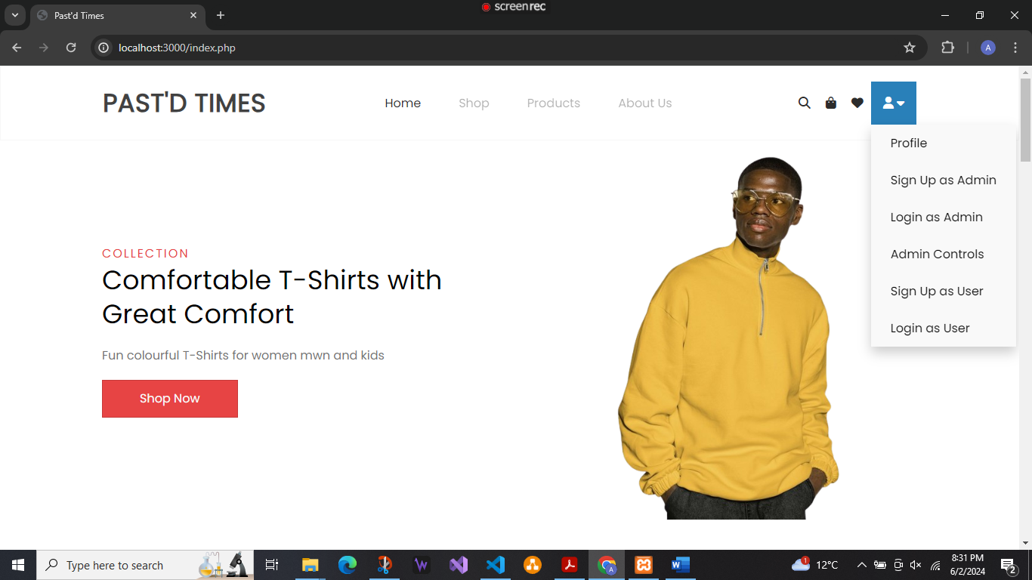

And then there is shop page where clothes is added by the admin for users to buy

And the products pages as well

And the cart where the purchases are made

And then there is an about us page

And its related pages

This is a rundown of our website and all its related pages and a brief description of how everything works.